SECTION 7: DATABASE AND STORAGE

—-------------------------------------------------------

The Four Categories of Storage-

Database Storage: The most common for application state. Includes SQL (optimized for complex queries and strict consistency) and NoSQL (optimized for flexible schemas and massive horizontal scaling).

Object Storage: Built for massive scale and durability of unstructured data. Files are stored as "objects" with metadata in a flat structure and accessed via REST APIs. Example: Amazon S3, Google Cloud Storage.

File Storage: Traditional hierarchical storage (folders and directories) accessed over a network. Commonly used in legacy enterprise systems where multiple users/servers need shared access to files. Example: NFS (Network File System).

Block Storage: Highly performant, low-latency storage that provisions raw storage blocks. This acts like a direct hard drive attached to a server. It is primarily used by operating systems or databases that require incredibly fast input/output (I/O) operations. Example: Amazon EBS.

Core storage properties- durability, availability,consistency,atomicity

Polyglot persistence- using different data storage techniques in a single application.

Types of NoSQL databases-

A. Document Databases (e.g., MongoDB)
- How it works: Stores data as flexible, JSON-like documents. Each document can have completely different nested fields and arrays.
- Best for: User profiles, content management systems, e-commerce product catalogs where items have varying attributes.

B. Key-Value Stores (e.g., Redis, DynamoDB)
- How it works: An ultra-simple, lightning-fast "hash map" structure. You have a unique key, and it points to a specific value (a string, a JSON blob, etc.).
- Best for: Caching layers, user session management, and shopping carts.

C. Columnar Databases (e.g., Cassandra, HBase)
- How it works: Instead of storing data row-by-row, data is stored grouped by columns. This allows the system to read massive amounts of specific metrics without reading irrelevant data.
- Best for: Analytics, processing massive server logs, time-series data, and extremely high write-heavy workloads.

D. Graph Databases (e.g., Neo4j)
- How it works: Focuses entirely on relationships. Data is stored as "Nodes" (entities) connected by "Edges" (relationships).
- Best for: Social networks (friends of friends), recommendation engines ("users who bought this also bought..."), and fraud detection networks.

BASE properties of noSql- basically available, soft state, eventually consistent

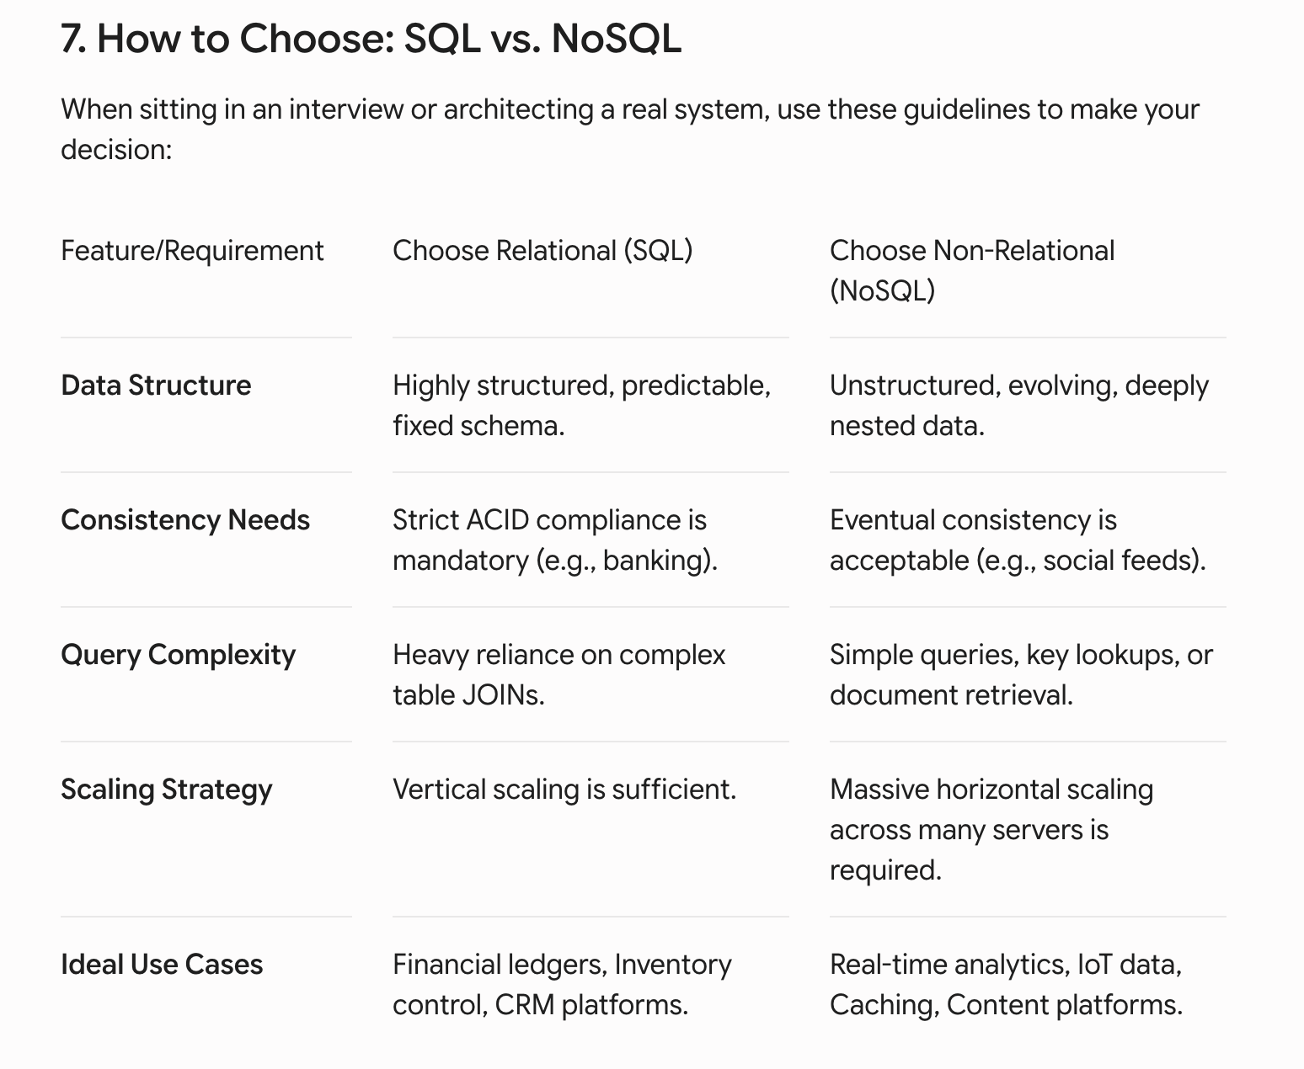

Vertical scaling is called scaling up
Horizontal scaling is referred to as scaling out.
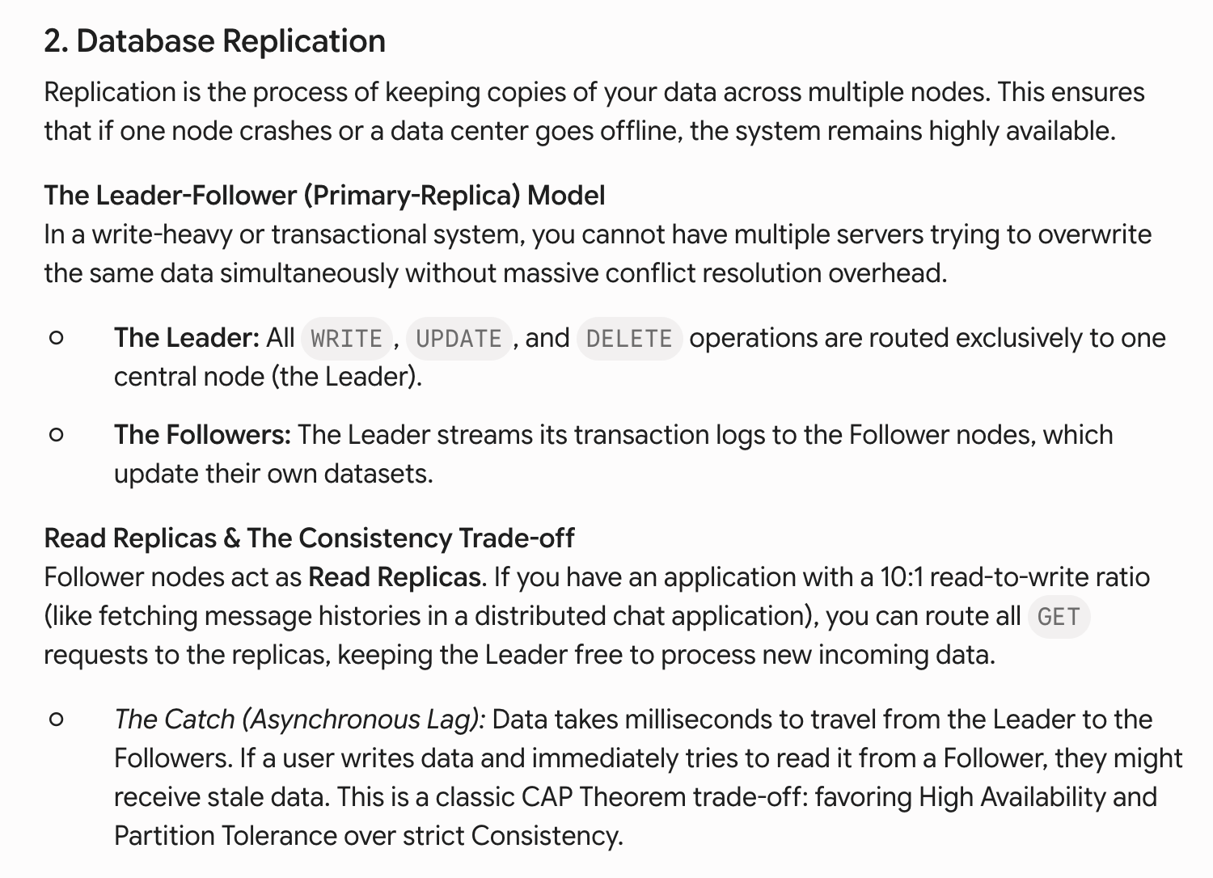

Vertical sharding- splitting data by functional domain. User authentication to server A and others to B
Horizontal sharding- splitting a single massive table across multiple servers.
Range based, geo-based, has-based

OBJECT STORAGE-

Storage is in the form of objects, in the form of flat namespaces,

So the object has 3 parts- the data, the key, and the metadata

The metadata has system attributes, content type, size, last modified time and custom tags. And these objects are stored in buckets

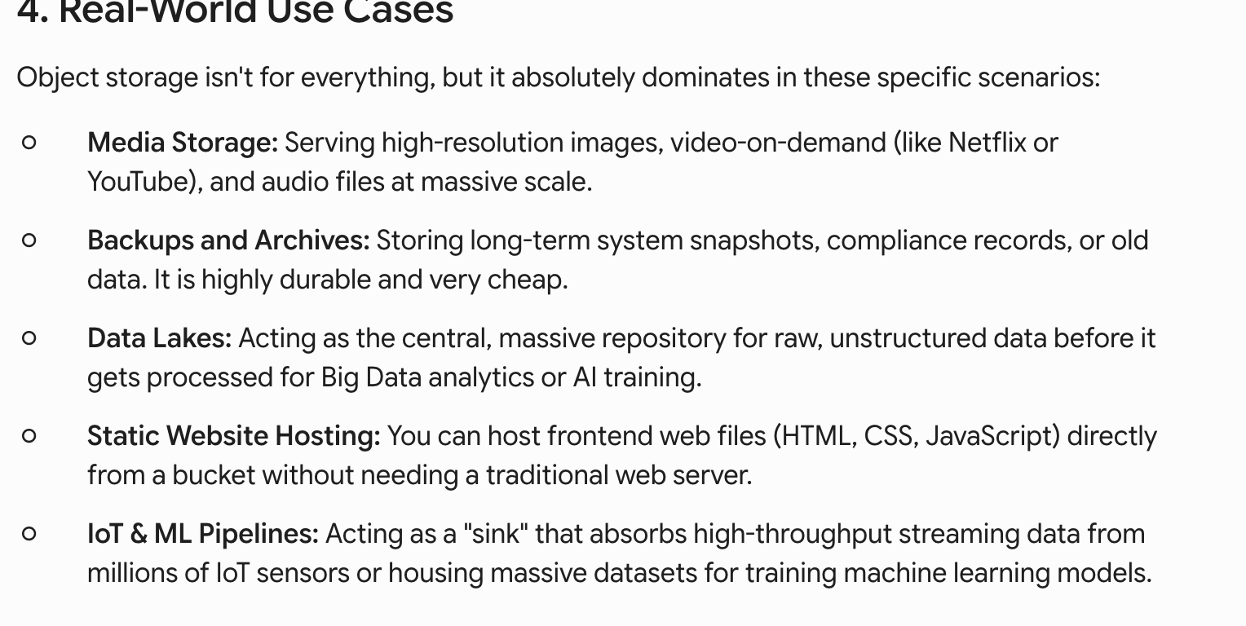

High throughput higer latency
Access pattern - WORM
File system jobs- managing metadata, structure directories, access control, hardware mapping

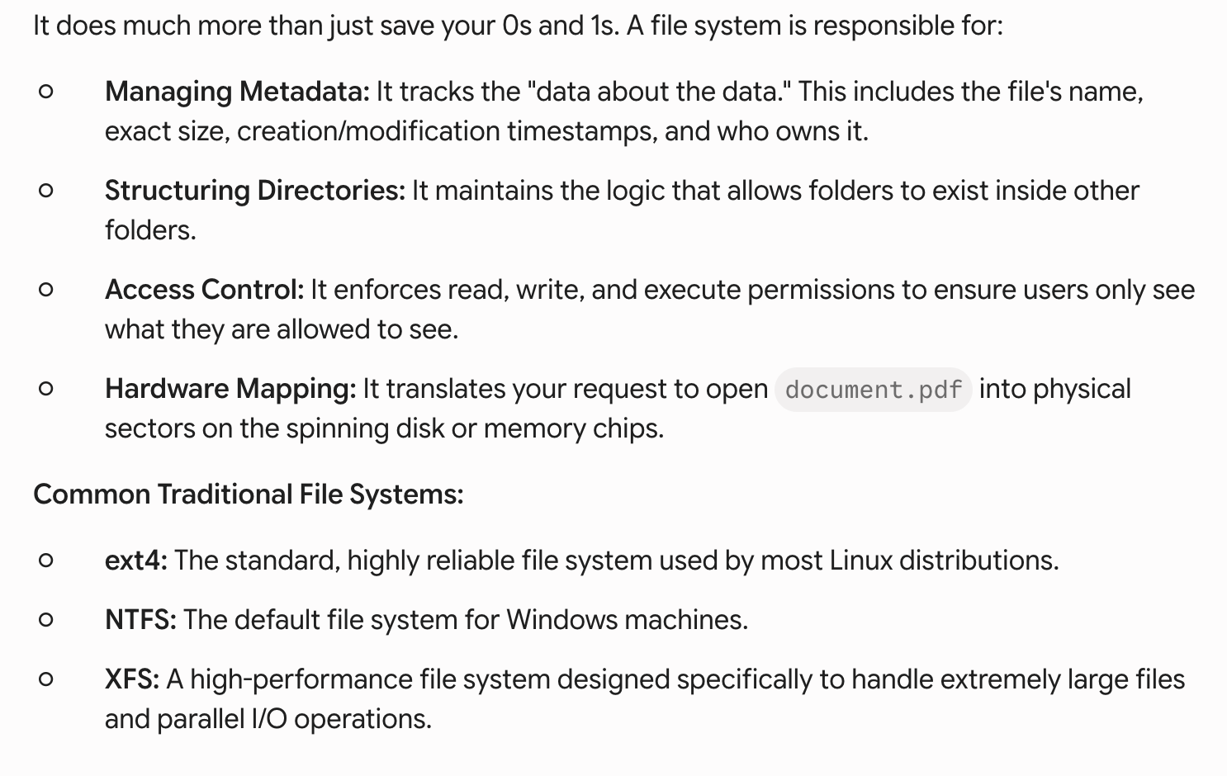

Issues scalability ceiling, single point of failure

Distributed file system break ur file into many tasks and store it across the dozens of the servers. Example- hadoop distributed file system.

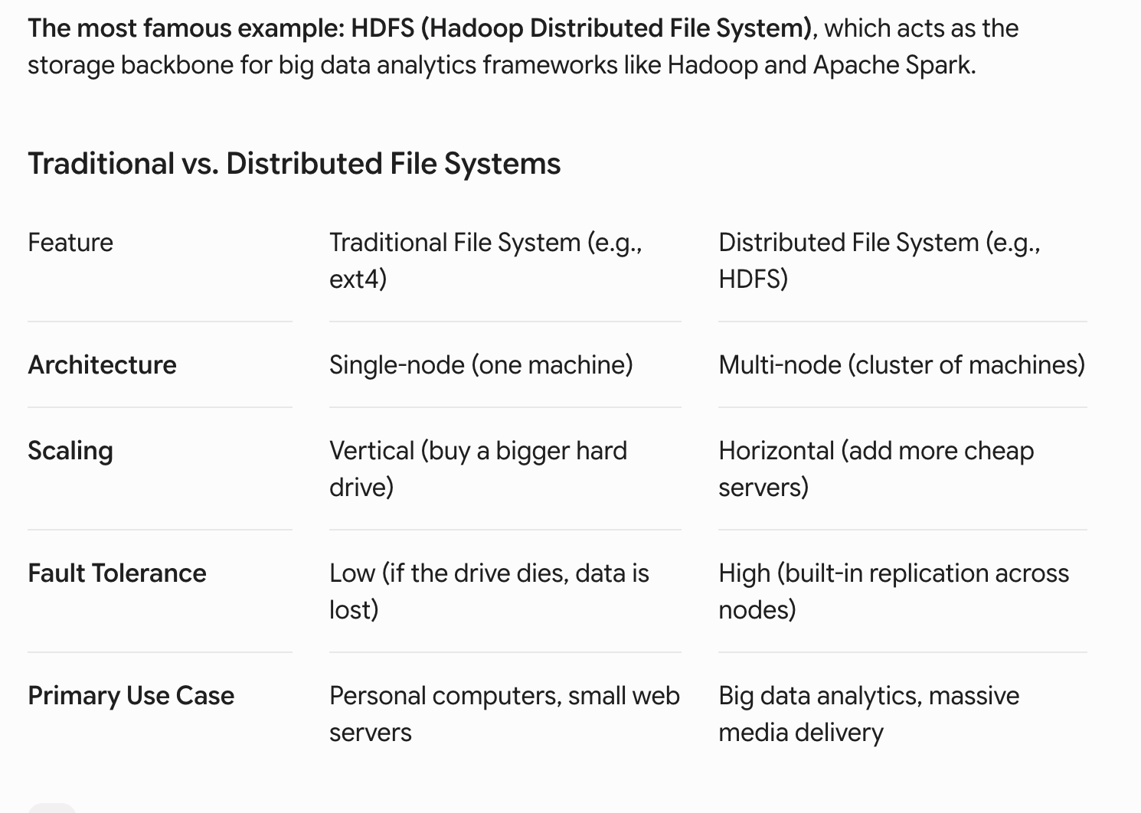

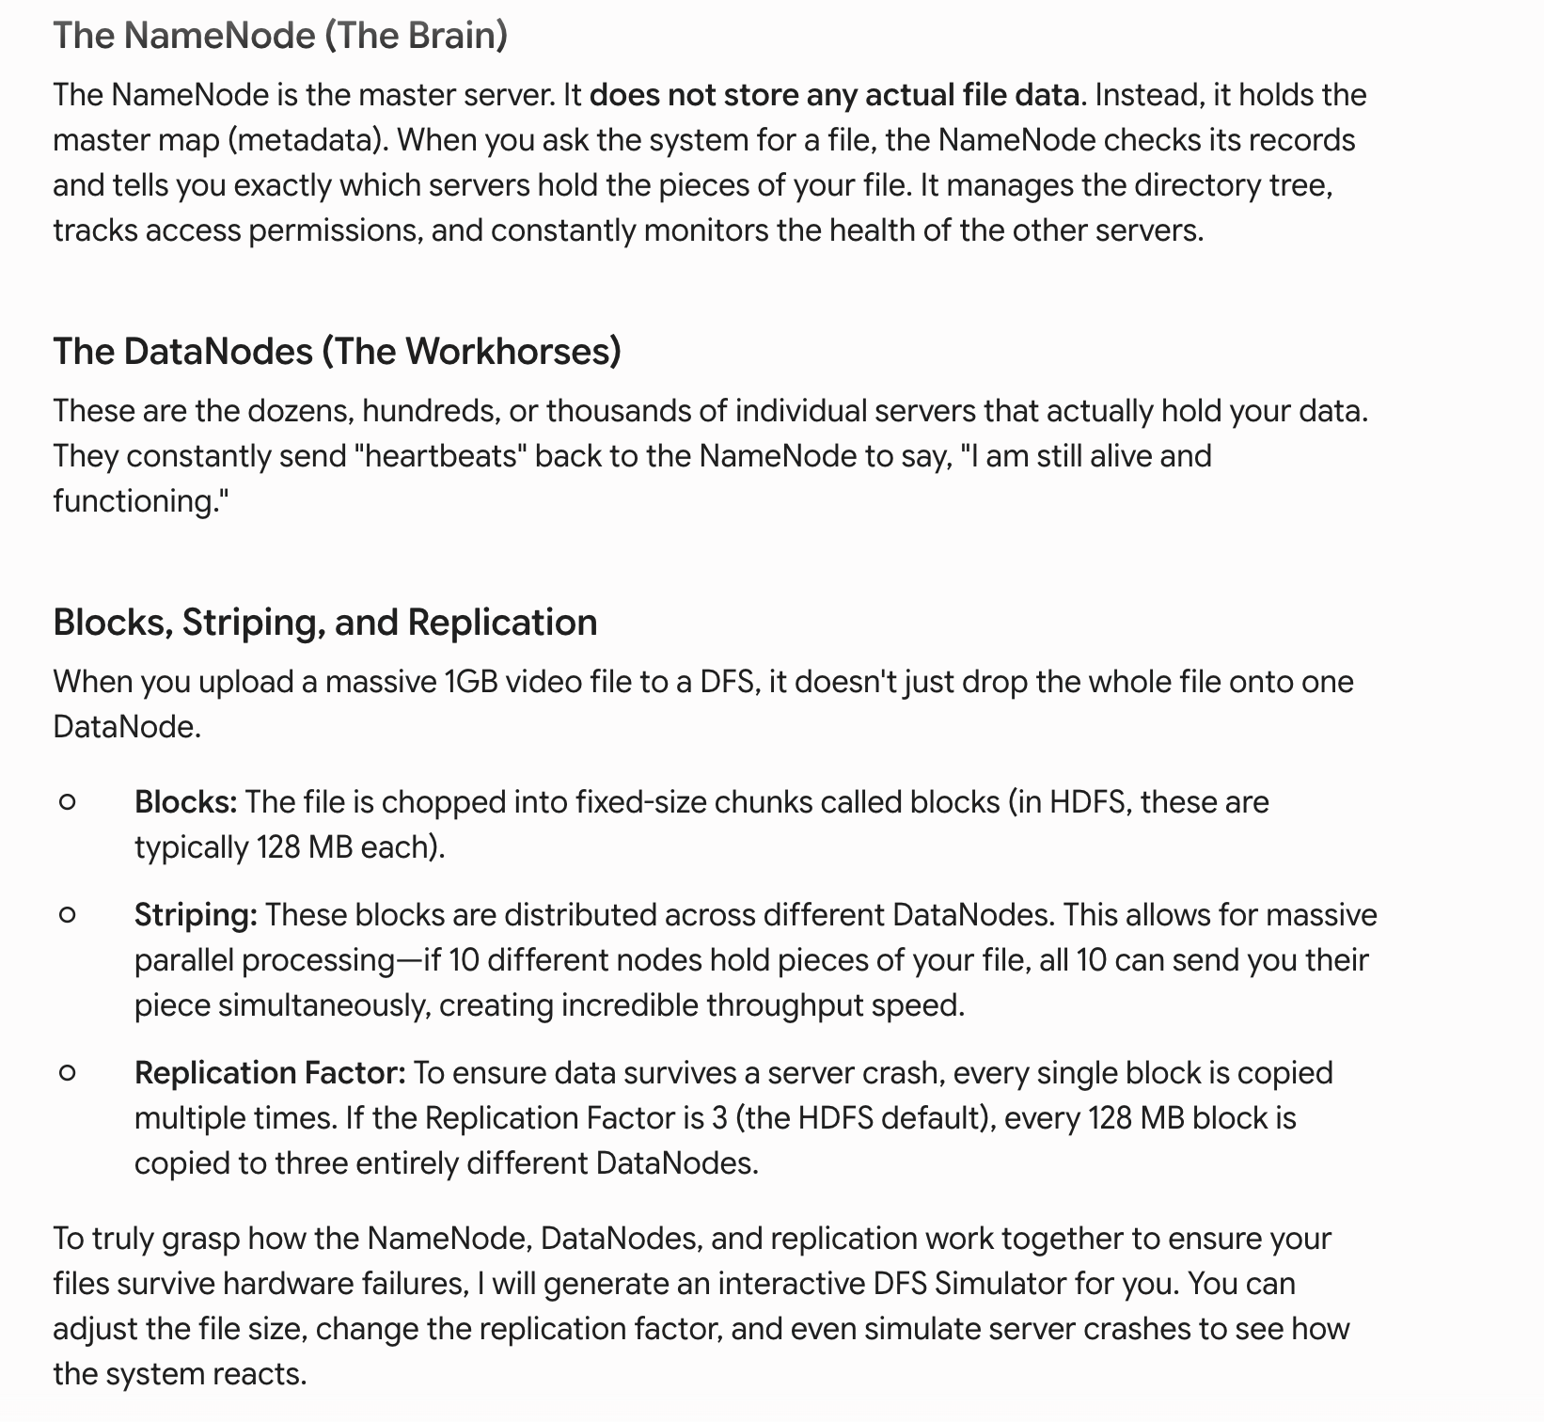

Benefits- limitless horizontal scalability, automatic rebalancing, self healing fault tolerance 